1. A circular bar with diameter 2 inch and length of 20 inch is fixed at one end and then is loaded at the other end by a downward force of 2 kip and a torsional moment of 30 kip ∙ in. Determine the absolute maximum shear stress at the top of the shaft (point A). (10’ in total)
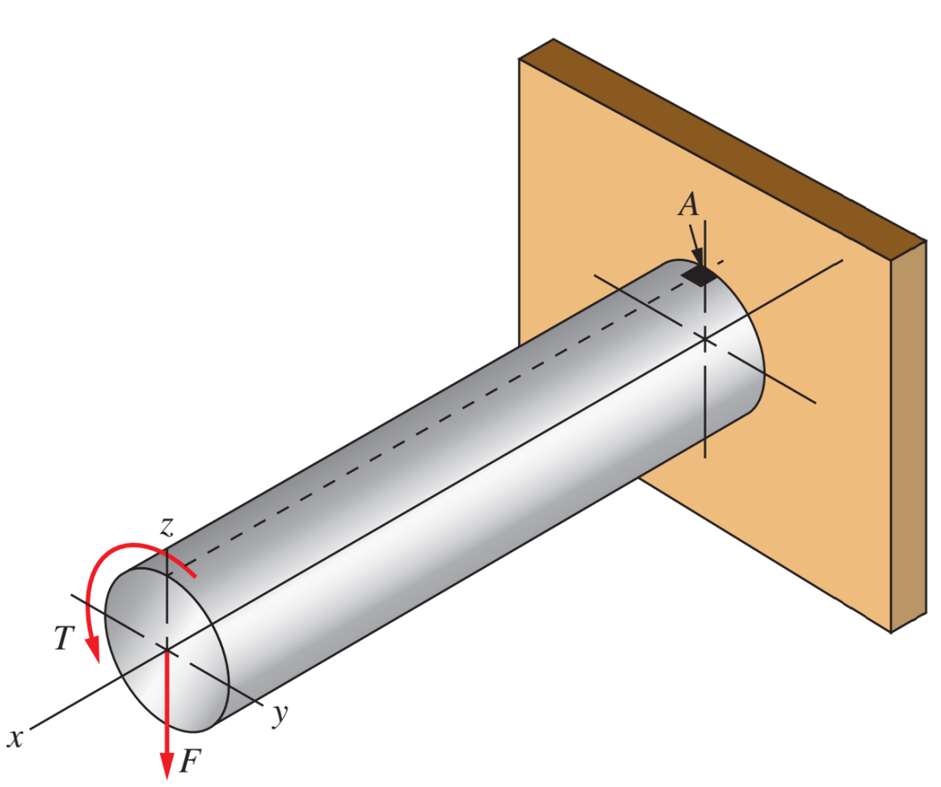
$$M_{max}=40\left[kip⋅in\right]$$
$$Z_{p}=\frac{πD^{3}}{16}=\frac{π2^{3}}{16}=\frac{π}{2}$$
$$S=\frac{πD^{3}}{32}=\frac{π}{4}$$
$$σ=\frac{M}{S}=\frac{40}{\left(\frac{π}{4}\right)}=\frac{160}{π}≅50.93$$
$$τ=\frac{T}{Z_{p}}=\frac{30}{\left(\frac{π}{2}\right)}=\frac{60}{π}≅19.10$$
MOHR Circle
$$σ_{x}=\frac{160}{π};σ_{y}=0;τ_{xy}=\frac{60}{π}$$
$$τ_{max}=\sqrt{{\left(\frac{\left(\frac{160}{π}\right)}{2}\right)}^{2}+{\left(\frac{60}{π}\right)}^{2}}=31.83 \left[ksi\right]$$

2. A horizontal beam supported by a vertical tension link. Determine the minimum width of a rectangular cross section for member C-D (the height must be 3 times of width), so that the maximum normal stress in member C-D does not exceed 500 MPa. The dashed line in the cross section indicates the axis along which the bending occurs. (15’ in total)
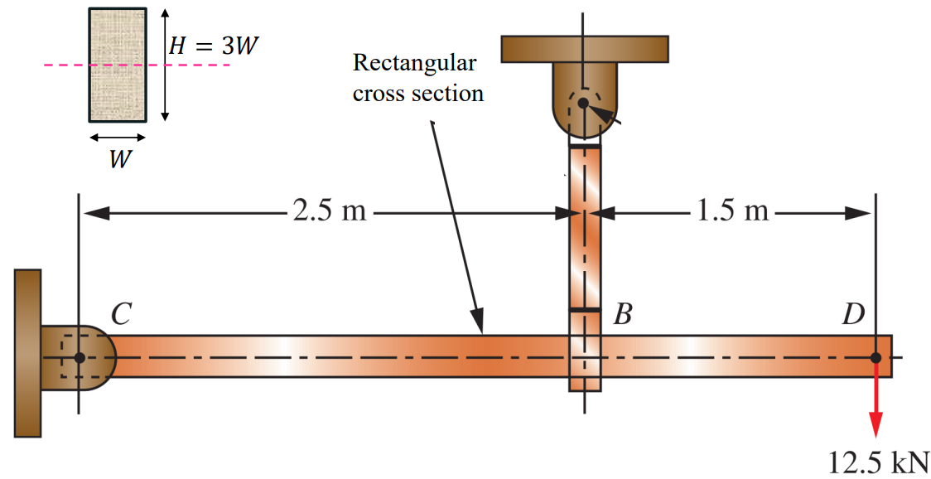
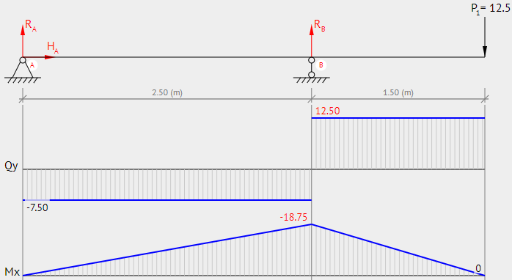
$$S=\frac{B*H^{2}}{6}=\frac{B*{\left(3*B\right)}^{2}}{6}=\frac{3B^{3}}{2}$$
$$σ=500MPa=500*{10}^{6}=\frac{M}{S}=\frac{18750}{\frac{3B^{3}}{2}}→B≅0.0292m=2.92cm$$

3. The diameter of the main shaft portion, labeled A, B, and C is 8.736 in. The left load 20 kip remains constantly applied, while the right load is applied and changes from 40 to 80 kip as the machine cycles. Determine the stress ratio for the point B. Also, for the same point, use the maximum shear stress theory to determine a specific material type under Aluminum alloy 2219. Take safety factor 𝑁 = 5. (25’ in total)
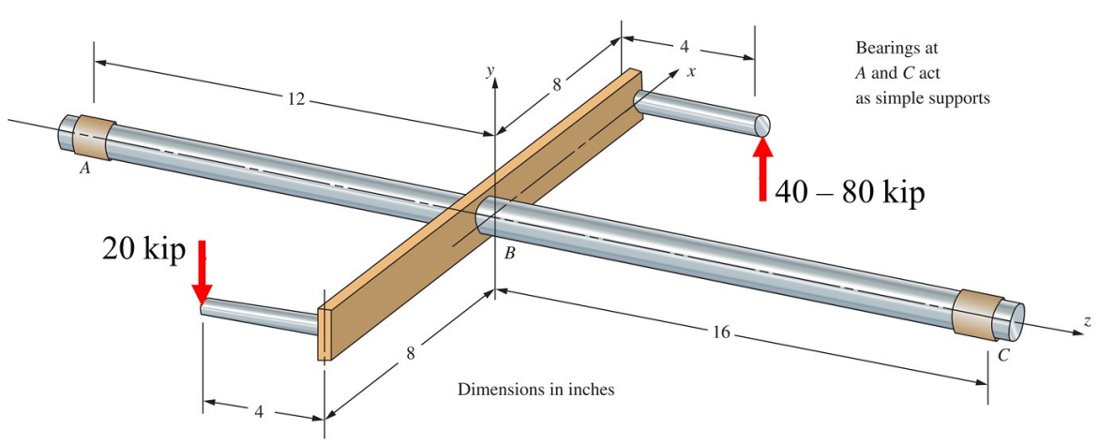
$$T_{min}=20*8+40*8=480\left[kip⋅in\right]$$
$$T_{max}=20*8+80*8=800\left[kip⋅in\right]$$
$$M_{min}=20*4+40*4=240\left[kip⋅in\right]$$
$$M_{max}=20*4+80*4=400\left[kip⋅in\right]$$
$$F_{min}=20\left[kip\right]↑;F_{max}=60[kip]↑$$
Moment Diagrams
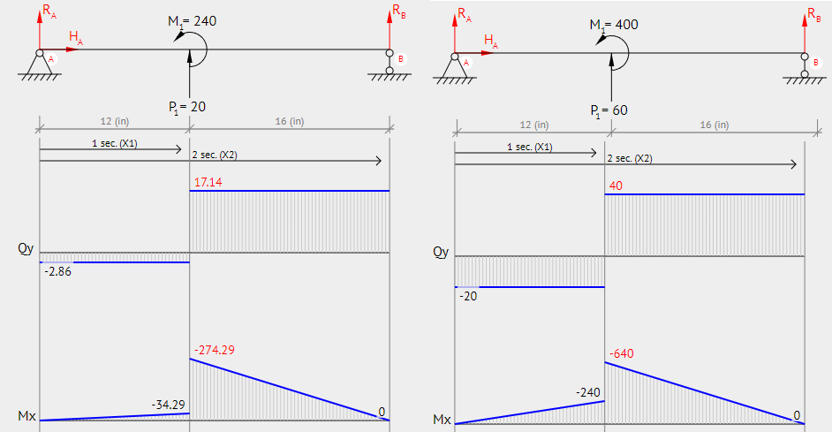
$$S=\frac{πD^{3}}{32}=\frac{π{8.736}^{3}}{32}≅65.45$$
$$Z_{p}=\frac{πD^{3}}{16}=\frac{π{8.736}^{3}}{16}≅130.9$$
Option #1(Normal Stress)
$$σ_{min}=\frac{M}{S}=\frac{274.29}{\left(\frac{π{8.736}^{3}}{32}\right)}=4.19[ksi]$$
$$σ_{max}=\frac{M}{S}=\frac{640}{\left(\frac{π{8.736}^{3}}{32}\right)}=9.78[ksi]$$
$$Stress Ratio=R=\frac{4.19}{9.78}=0.428$$
$$σ_{x}=9.78;σ_{y}=0;τ_{xy}=0$$
$$τ_{max}=\frac{9.78}{2}=4.89\left[ksi\right]$$
MSST:
$$τ_{max}≤\frac{S_{y}}{2N}→4.89≤\frac{S_{y}}{2*5}→48.9≤S_{y}$$
Material:
ONLY Aluminum 2219-T87 meets the requirements of 48.9[ksi] as determined above.

4. The shaft is rotating at 1750 rpm, and it receives 7.5 hp through a 5.00-in V-belt drive from a mating belt sheave directly below. The power is delivered by a wormgear with a pitch diameter of 2.00 in. The forces on the wormgear are shown in the figure. Use SAE 1020 cold-drawn steel for the shaft material. (25’ in total)
1) Determine the torque at A. Also determine the torque distribution in A-B, B-C, and C-D region.
2) Plot the shear and bending moment diagrams for the A-B-C region of the shaft in the horizontal and vertical planes.
3) Determine the total bending moment at point C (for both to the left and to the right).
4) Determine the minimum acceptable diameters for the shaft at point C. Do the design to the left and to the right of point C separately. Take 𝐶𝑠 = 0.90, 𝐶𝑅 = 0.81, design factor 𝑁 = 4, stress concentration factor 𝐾𝑡 = 2.0.
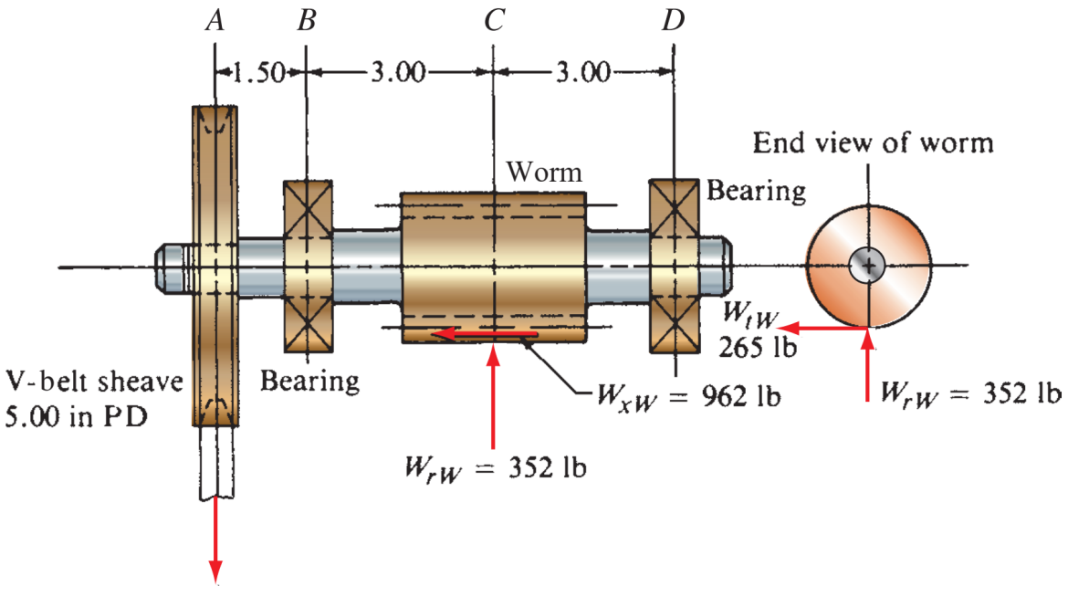
$$Torque\left(A\right)=A-B=B-C=\frac{63000*7.5}{1750}=270$$
$$T_{CD}=0$$

$$F_{A_{Y}}=1.5\frac{T_{A}}{R}=1.5*\frac{270}{2.5}=-162$$
$$F_{C_{Y}}=352$$
$$F_{C_{X}}=265$$
$$M_{C}=962*1=962$$
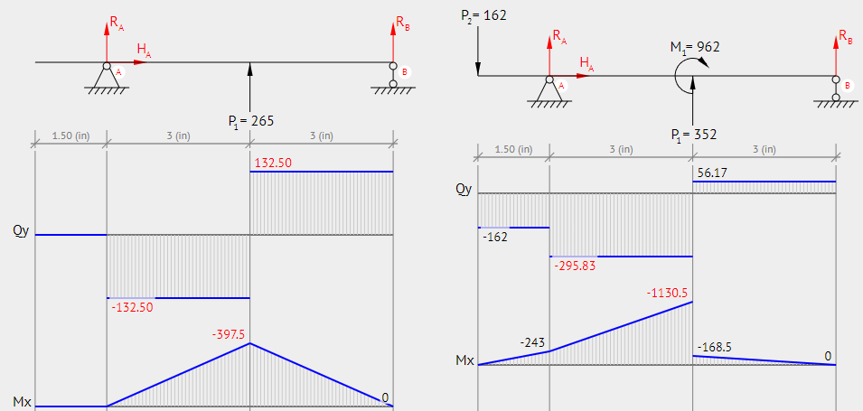
$$C_{Left}=\sqrt{{397.5}^{2}+{1130.5}^{2}}=1198.3$$
$$C_{Right}=\sqrt{{397.5}^{2}+{168.5}^{2}}=431.7$$
$$S_{y}=51, S_{u}=61$$
$$S_{n}=23$$
$$S_{n}^{'}=23*0.81*0.9=16.767$$
$$D_{Left}={\left(\frac{32*N}{π}*\sqrt{{\left(\frac{K_{t}M}{s_{n}^{'}}\right)}^{2}+\frac{3}{4}{\left(\frac{T}{s_{y}}\right)}^{2}}\right)}^{1/3}={\left(\frac{32*4}{π}*\sqrt{{\left(\frac{2*1198.3}{16767}\right)}^{2}+\frac{3}{4}{\left(\frac{270}{51000}\right)}^{2}}\right)}^{1/3}=1.80\left[in\right]$$
$$D_{Right}={\left(\frac{32*N}{π}*\sqrt{{\left(\frac{K_{t}M}{s_{n}^{'}}\right)}^{2}+\frac{3}{4}{\left(\frac{T}{s_{y}}\right)}^{2}}\right)}^{1/3}={\left(\frac{32*4}{π}*\sqrt{{\left(\frac{2*431.7}{16767}\right)}^{2}}\right)}^{1/3}=1.28[in]$$

5. The stepped rod shown is subjected to a direct tensile force that varies from 8500 to 16 000 lb. If the rod is made from SAE 1340 OQT 700 wrought steel, use Goodman criterion to determine the design factor. Take reliability as 90%. Stress concentration needs to be considered at point B. (15’ in total)
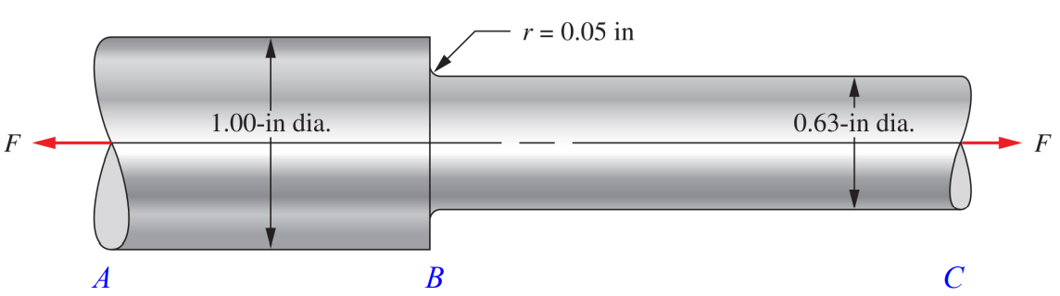
$$\frac{K_{t}σ_{a}}{s_{n}^{'}}+\frac{σ_{m}}{s_{u}}=\frac{1}{N}$$
$$K_{t}=1.95$$
$$σ_{max}=\frac{16000}{π*\frac{{0.63}^{2}}{4}}=51.327\left[ksi\right]$$
$$σ_{min}=\frac{8500}{π*\frac{{0.63}^{2}}{4}}=27.267\left[ksi\right]$$
$$σ_{a}=\frac{51.317-27.267}{2}=12.025\left[ksi\right]$$
$$σ_{m}=\frac{51.317+27.267}{2}=39.292\left[ksi\right]$$
$$S_{u}=221;S_{y}=197$$
$$C_{R}=0.9;C_{m}=1;C_{st}=0.8;C_{s}=1;S_{n}=66.5$$
$$S_{n}^{'}=S_{n}C_{R}C_{m}C_{st}C_{s}=0.9*1*0.8*1*66.5=47.88$$
$$N=\frac{1}{\frac{K_{t}σ_{a}}{s_{n}^{'}}+\frac{σ_{m}}{s_{u}}}=\frac{1}{\frac{1.95*12.025}{47.88}+\frac{39.292}{221}}=1.5$$

6. A toggle device is being used to compact scrap steel shavings. Design a suitable diameter for the left link of the toggle to be steel, SAE 5160 OQT 1000, with a circular cross section and pinned ends. The force P required to crush the shavings is 5000 lb. Use safety factor 𝑁 = 3.50. (10’ in total
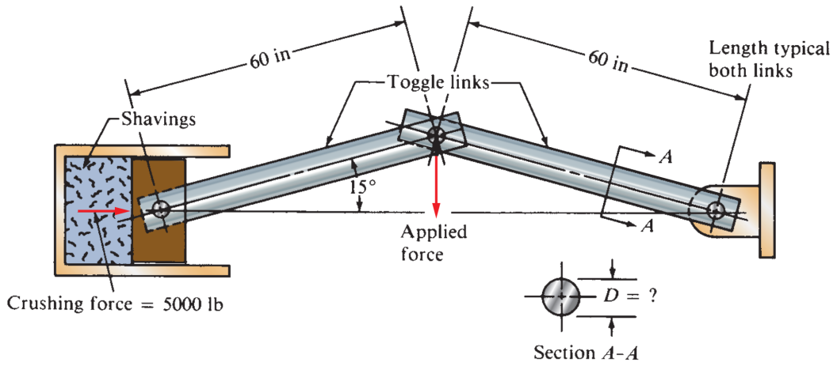
$$D={\left(\frac{64NP{\left(KL\right)}^{2}}{π^{3}E}\right)}^{\frac{1}{4}}$$
$$K=1;E=30*{10}^{6}$$
$$D={\left(\frac{64*3.5*5000{\left(1*60\right)}^{2}}{π^{3}*30*{10}^{6}}\right)}^{\frac{1}{4}}=1.44$$

